**Goal size for prosthetic hand:**

**Overall Length:** 180.5 mm (wrist to longest finger)

**Overall Width:** 79mm (across widest part of palm)

**Finger Width** = (Palm Width)/4 = 19.75 mm

Source: <http://www.theaveragebody.com/average_hand_size.php>

(Values were obtained by averaging the average male and female hand size)

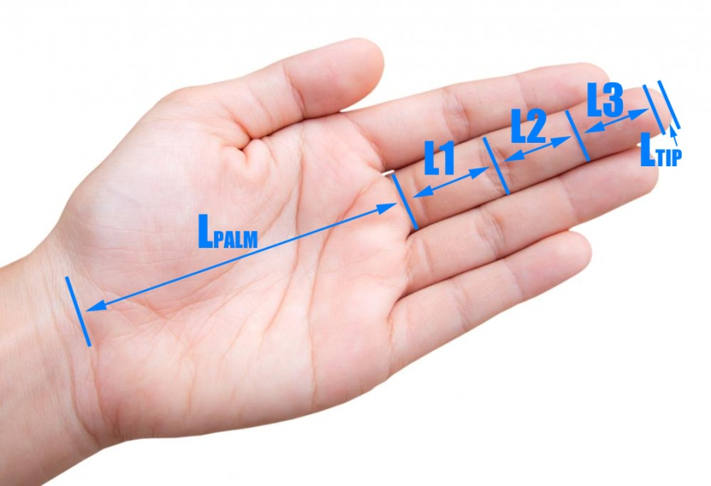**Hand Segment Lengths:**

**L1** = 44.63 mm

**L2** = 26.33 mm

**L3** = 17.4 mm

**Ltip** =3.95 mm

Lpalm = Overall Length – Length of Fingers

= 180.5-(L1+L2+L3+Ltip)

**Lpalm** = 88.19 mm

Source: “Proportions of Hand Segments” (also in this folder)

Finger lengths above refer to segments of the middle finger. L1, L2 and L3 are lengths of finger segments (joint to joint), Ltip is the length of the padded part at the tip of the finger. We can choose to wrap the granular jamming pads up and over the tip of the finger to model this (which I think is a cool idea), or just truncate it.

I suggest making all the fingers the same length (at first), the length of the middle finger, so that they’re maximally useful while also being interchangeable.

If you don’t want to make the fingers all the same length (something I might recommend trying after one prototype), then real fingers follow a ratio:

**Finger Length Ratios:**

**Index Length** = 0 .8*(Middle Length)

**Ring Length** = 0.93*(Middle Length)

**Pinky Length** = 0.74*(Middle Length)

Source: “Relative Lengths of Fingers and Toes in Human Males and Females” (also in this folder)

**Thumb Proportions:**

**I can’t find data on thumb proportions. There’s a length that sort of resides inside your palm, and then two lengths outside the palm (and the padded part at the tip). All three lengths are relevant. If you would like to make it a goal to find scientific data on average lengths of the segments of the thumb, I would greatly appreciate it!**

**Weight:**

**Weight of the hand** = 425.7 grams

**Weight of the hand & forearm** = 1,699.1 grams

It is just as important to keep the hand at a proper weight as it is to keep it at the proper size! A person with more weight on one side than the other will subconsciously lean to the side where they have less weight, cause long-term problems with their spine.

**Weight Calculations (to show where the weight values came from):**

Weight of the hand* = 0.575%

Weight of the hand & forearm* = 2.295%

*as expressed as percentage of total bodyweight

Source: <http://www.exrx.net/Kinesiology/Segments.html>

Average human weight: 74.035 kg

Source: <http://www.theaveragebody.com/average_weight.php>

(found by taking the average of all male values, then the average of all female values, and then the average of those averages.

Weight of the hand = (.00575)*(74.035) = .4257 kg = 425.7 grams

Weight of the hand & forearm = (.02295)*(74.035) = 1.6991 kg = 1,699.1 grams